Why 2027 - 2030 Is the Strategic Moment
Context
The Eviana TOA DP Capital Partnership is timed deliberately. It aligns Development Permit approval with the 2026 - 2027 macro window, when multiple high-probability forces converge to support condo pricing, presale absorption, and capital flows in Metro Vancouver. This timing is not speculative; it is grounded in visible policy timelines, interest rate cycles, supply constraints, and TOA legislation already in place.
Key Drivers for 2027
Interest Rate Path
Central banks are expected to normalize interest rates downward through 2026 - 2027. Lower financing costs increase purchasing power for end-buyers and improve construction feasibility. Historically, rate normalization accelerates presale velocity and raises achievable pricing for well-located projects.
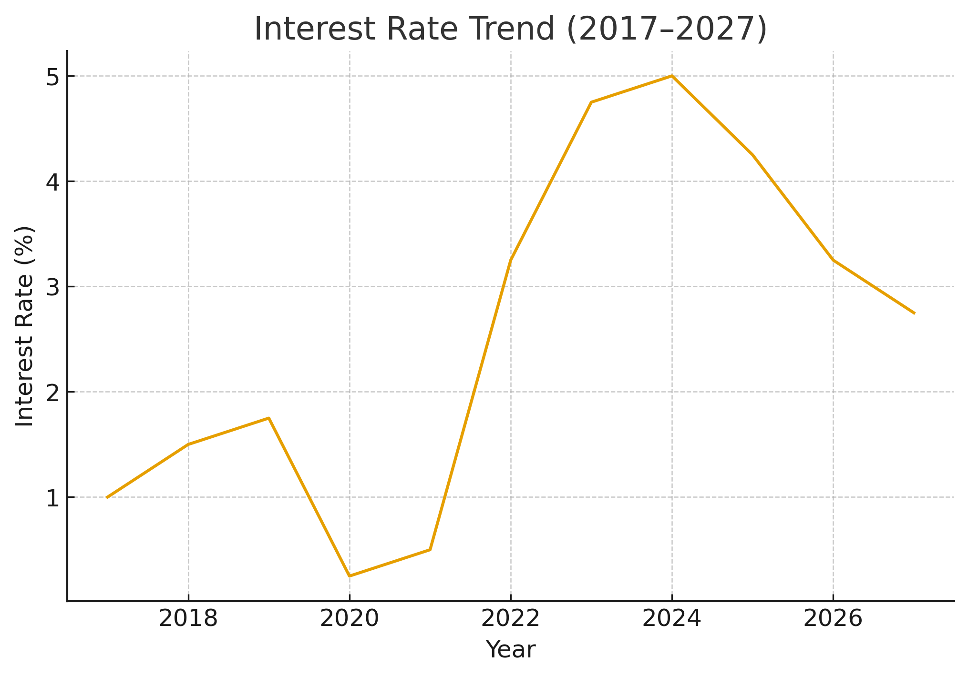

Foreign Buyer Policy Reset (January 2027)
Current federal and BC restrictions on foreign buyers are time-limited. If not extended, they ease or expire in January 2027. When international capital re-enters, it concentrates on transit - connected nodes, brand-aligned projects, and supply-constrained corridors, all of which describe Burquitlam’s TOA zone.
Structural Housing Undersupply
Metro Vancouver continues to underbuild relative to population growth. High construction costs and financing rates have delayed many competing projects. By 2027, the market will feel the impact of this supply gap through stronger pricing and record absorption for mid-rise homes near transit.
This TOA site benefits further from its proximity to SFU, Lougheed Centre, and multiple transit-linked employment clusters, reinforcing demand from students, professionals, downsizers, and rental tenants.
TOA (Transit-Oriented Area) Policy Advantage
Provincial TOA policy prioritizes housing density around SkyTrain stations and requires municipalities to support these corridors. This reduces political risk, accelerates approvals, and increases lender confidence. A DP-approved TOA site in 2026 is positioned as a first-priority project type for both capital and future buyers.
Why Align DP for 2026
Completing DP around 2026 creates three structural advantages:
1. Crystallized DP Land Uplift: The increase in land value occurs before the broader market acceleration.
2. Strategic Optionality: At DP approval, the investor may sell the DP-approved site, launch presales, or Joint Venture with a builder without losing economic leadership.
3. Competitive Timing Advantage – Competing projects will still be in rezoning or DP queues; this project will be ready, not waiting.
4. The assembly is already positioned in the City of Coquitlam’s Development Permit queue, ensuring it advances through the established review stream and is not subject to new application delays.

Implications for the Eviana DP Capital Investor
• You are aligning with a visible, policy-backed, high-probability window, not speculating on an unknown cycle.
• TOA designation and DP-ready status create a defensible risk-adjusted profile in an undersupplied node.
• Your 80% share of development profit is tied to a period where structural and macro tailwinds are strongest.
• Participation now places you ahead of the 2027 - 2030 wave, not behind it.
Bottom Line
This timing is engineered where policy, rates, supply, and capital flows converge. This is where the investor gains maximum leverage with minimal ambiguity.

